Submission Guidance for abstracts if you would like to present a paper or poster:
Submission Deadline: Jan 31, 2019
- For presentations:
*Submit up to a 4 page summary (excluding 350 word abstract, references, etc.)
Format references according to IEEE standard
- For posters:
*Submit 350 word abstract
*Submit a PowerPoint slide depicting your 34” high x 44 ” wide poster design
- Enter the TITLE of your presentation or poster in the Presentation Title field.

- Enter the presenter information.

- Enter the 350 word abstract.

- Please indicate whether you are submitting a Presentation or a Poster by noting it in the Comments field of your submission form (see image below).
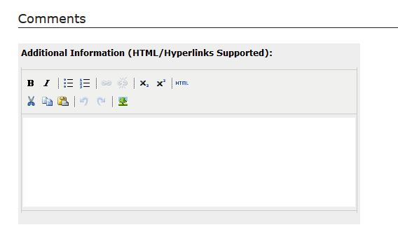
- Upload the poster PowerPoint slide or the (four page max) presentation summary.

Acceptance notification will be sent out NLT 7 days following submission of work. To submit your abstracts and more information can be found at the submission website. https://docs.lib.purdue.edu/can
Talks (Papers) and Poster Submissions should fit within the following topics:
- Radiation Measurements (improved/unique methods; modeling)
- Threat Reduction Policy
- Counter-Proliferation + Treaty Verification
Paper Guidelines:
- Four (4) pages maximum (does not include abstract, references, keywords, and author(s) bio)
- Abstract will be 350 words max and must sufficiently summarize work. Paper and presentation’s acceptance will be heavily based upon the content of the abstract to see if the subject adequately meets the objectives of the technical program (so ensure the abstract is a good representation of the paper and presentation).
- Format using 12-point font, Ariel, 1.5 spacing, 1-inch margins, and single column.
- Cite work according to IEEE citation guidelines. https://journals.ieeeauthorcenter.ieee.org/your-role-in-article-production/ieee-editorial-style-manual/
- Papers will receive two rounds of peer-review. One will occur prior to the conference. The second will occur after the conference where the author(s) will be asked to address comments they received from the first iteration of peer-review and from feedback received at the conference.
- Author(s) must resubmit their paper with corrections from the second iteration of peer-review (following the conference) to have paper published in the conference proceedings.

Presentation Guidelines:
- Presenters will have twenty minutes to present, including time for questions at the end.
- Bring any speaking aides (e.g. PowerPoint slides) with you to the conference, to be uploaded in advance of your session

Poster Guidelines:
- Submit 350 word (max) abstract and PowerPoint slide depicting the 34” high x 44” wide poster you intend to bring with you to the conference on:
https://docs.lib.purdue.edu/can
- Abstract will be 350 words max and must sufficiently summarize work. Paper and presentation’s acceptance will be based upon the content of the abstract to see if the subject adequately meets the objectives of the technical program (so ensure the abstract is a good representation of the paper and presentation).
- Format using 12-point font, Ariel, 1.5 spacing, 1-inch margins, and single column.
- Cite work according to IEEE citation guidelines.
https://journals.ieeeauthorcenter.ieee.org/your-role-in-article-production/ieee-editorial-style-manual/
Copyright Information for Purdue’s Digital Repository
- Papers will be published to Purdue’s Digital Repository, ePubs
- Purdue ePubs License Agreement can be referenced at the following link:
https://www.lib.purdue.edu/repositories/epubs/about#copyright
- The following is an excerpt from Paragraph 3, Author Agreements and Copyright, taken from the Purdue University website above:
“Authors do not transfer copyright when submitting to Purdue e-Pubs but rather license the right for Purdue University to provide access to their scholarly material. By clicking on the license agreement, authors acknowledge that they have the authority to submit the work and that they will not infringe on anyone else’s copyright by doing so.”

Questions on content or need help? Please email Peter Nowicke (pnowicke@purdue.edu)

